**Description**

The Walking Dead: Our World

iOS, Android

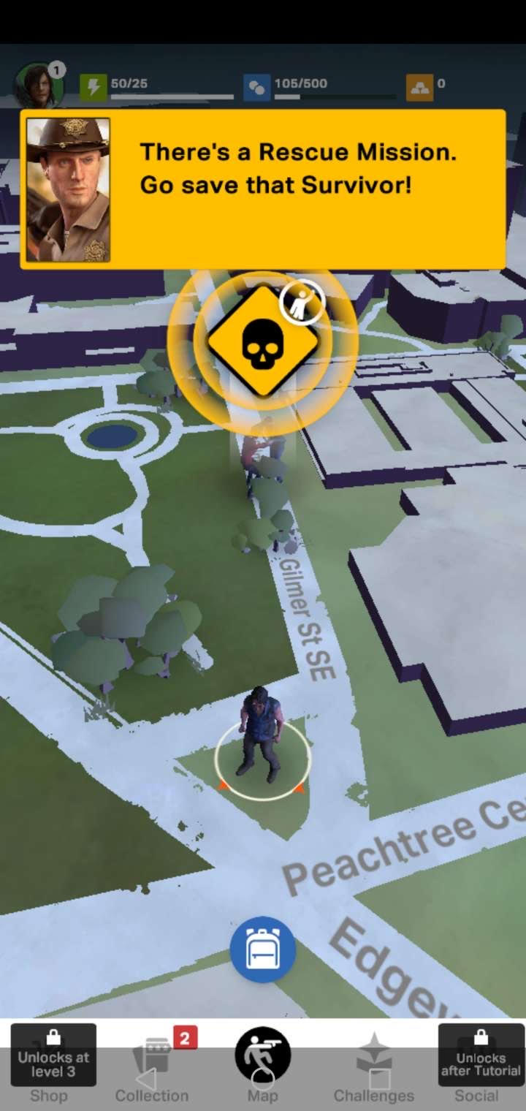

**Intended users**

Its Target audience are people who play similar games (Pokémon Go/Wizards Unite) and the fan base of the show.

The user needs are the ability to play the game, these include:

Ability to use without camera for AR

Ability to use game features with accessibility functions

Ability to play it on both Android and iOS

Ability to play on tablet (Android and iPadOS)

How have they been met?

The app has a permission setting for the app meaning that it doesn’t have to use AR to be played.

All apps on the App Store are compatible with accessibility function that are on iOS devices.

The app is playable on both Android and iOS since it is on both the App Store and the Play Store

The app is available on the Play Store meaning it can be played on Android Tablets. The app is available on the App Store for iPads so it is available for iPadOS

**Purpose of app**

The purpose of the app is to provide a game that uses GPS and Augmented Reality. It is a game that wants you to travel to locations to fight off numerous hordes of zombies and even place your base. Using this app while travelling mean you will be able to collect different items from the hordes as well as attack other bases. The app can be used with VR (similar to Pokémon Go), attacks can be done in VR so that your device uses your camera to show whatever is in front and the enemies on screen. This option can be disabled since they do have backgrounds ready if this was the preference. You can also collect characters from the TV series and weapons to help fight off the hordes.

**Current technologies**

What types of technology have been used in the development of the app?

* + This application works on Android, iOS and iPadOS devices.
  + The development language for Android was Java. The development language for iOS and iPadOS is swift.
  + The application is based off of the TV show, it was developed by Next Games, who also created their other game, TWD: No Man’s Land

Does the app make use of any particular technologies in its use?

* + The game uses GPS to recognise the location of the device and place it on a map that is real-time based. The app also uses the camera in order to use Augmented Reality.
  + The user interface is covered by the whole screen; it uses the touch screen in order for the user to interact.
  + The application uses several device permissions, the application cannot be played without access to the internet since it feeds off of a server, it also needs the internet access for the map. It can use either Wi-Fi or mobile data to connect to their servers. The app needs permission for the camera in order to use Augmented reality however the game is still playable even without this function being allowed.

**Evaluate**

The app is entertaining, especially for its intended user base. The app is developed by what seems like a new company and is sponsored by AMC in order to create this game, so they must be on a fairly large budget since AMC is a major broadcasting network in the United States.

The application should download map data and other live events so that if the connection is disrupted, the app can still be played locally and then the data could be uploaded while connection has been established. The downfall of this is that local data could be downloaded from a distributor meaning users can cheat by downloading other users game data and when internet connection is established it will upload the new data. This is one reason why games will instantly stop letting you play while the internet connection has been lost.

**Description**

Netflix

Android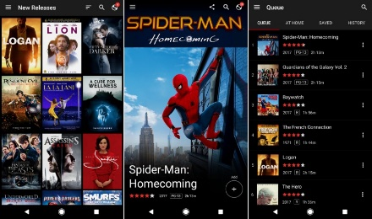, iOS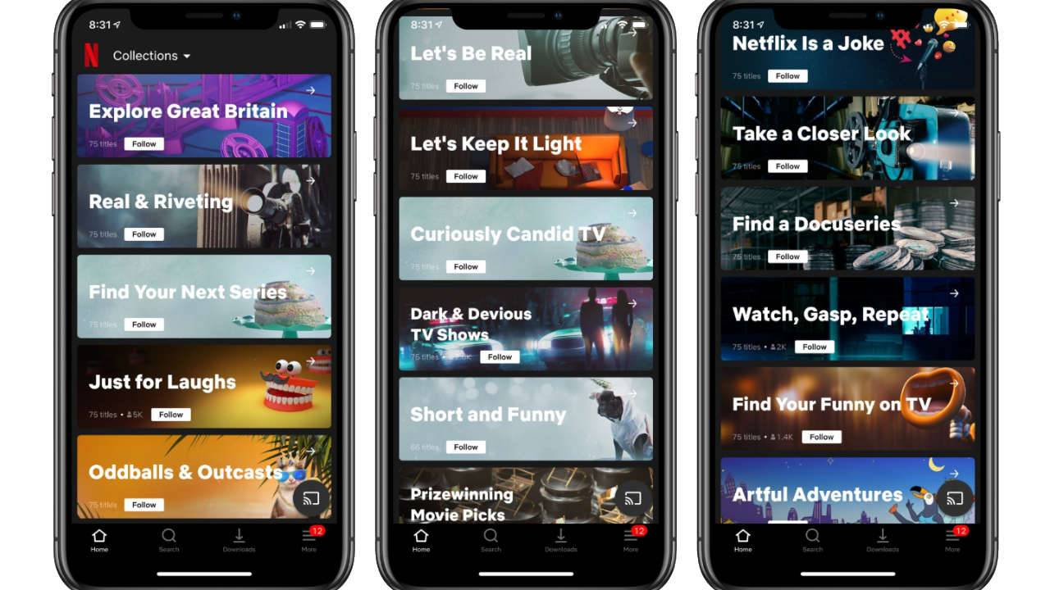

iPadOS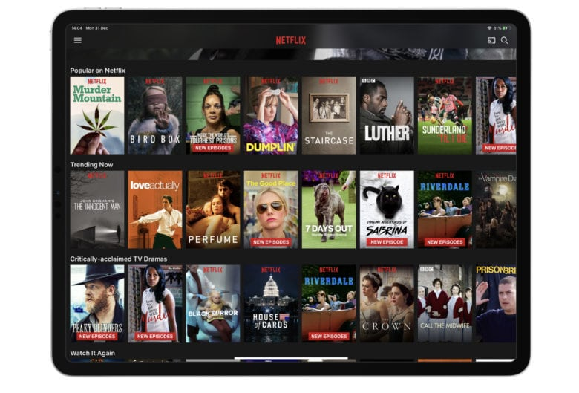

TvOS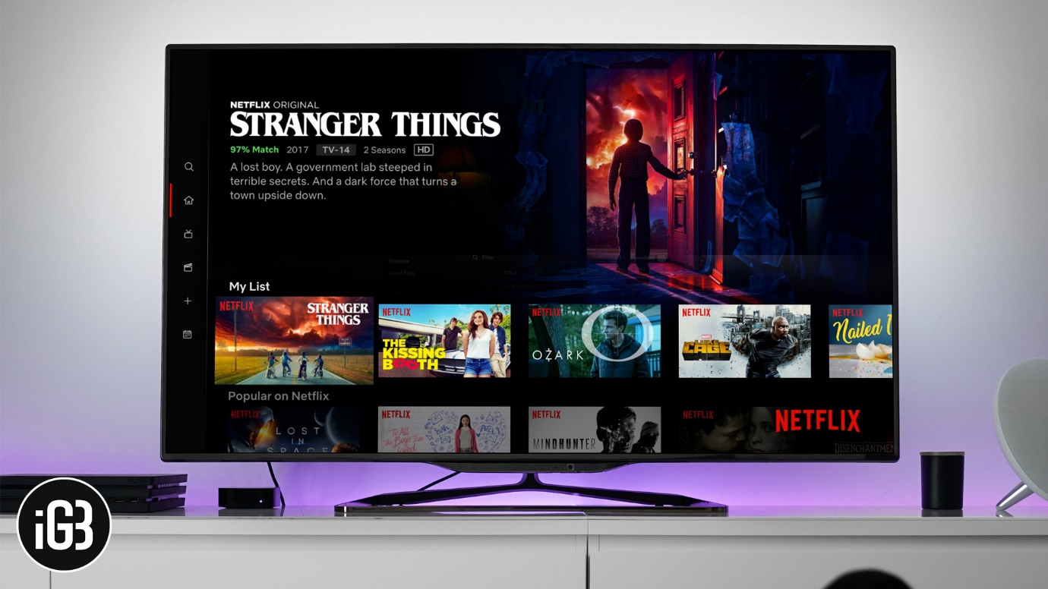

**Intended users**

The target audience for Netflix has a massive range, it goes from children to adults and even the elderly, there are categories on Netflix that could appeal to anyone.

User needs, preferences and characteristics – how have they been met?

User needs would be something such as, AD or Subtitles. Netflix caters to these people by allowing users to read subtitles that have been created by Netflix or the Show’s producers for people who are deaf or hard of hearing. It also has Audio Description which allows blind users to know what is happening due to a commentary over the top of the show or film.

**Purpose of app**

The purpose of Netflix is for users to be able to watch their favourite shows or films (that are on the platform). Whilst Netflix comes with a cost, it allows users to watch whatever shows are on the platform as many times as they possibly can or want. Netflix allows for five different users to have an account on there, this means it can be shared with friends and/or family. Netflix is an entertainment application; they are becoming popular on mobile devices more and more every day. This is because the portability of a mobile device added with the convenience of TV shows and films being on applications on their devices means it

**Current technologies**

What types of technology have been used in the development of the app?

* + Android, iOS, iPadOS, TvOS
  + Python
  + Their Development was done through a small group of people, they

Does the app make use of any particular technologies in its use?

* + The app uses data from the device and account for shows they have watched and changes the cover photos for other shows based on the genres of shows that have been watched.
  + The app uses full screen in order to view shows better on both Android and iOS. On iPadOS, you can use another app whilst watching Netflix, the show will be in a small box on either corner of the screen while the user is doing something else as well. If the small box is blocking the view, it can be easily moved by swiping as well as being able to hide it by swiping towards the edge of the screen.
  + The app requests access to Bluetooth in order to use Bluetooth accessories.

**Evaluate**

Netflix is an incredibly popular application that has sold to many people in fact there are 150 Million users on Netflix, which is about 37% of all internet users. Netflix has many different features that separate if from any other show watching application such as My5, all 4, ITV Hub etc. one of these features is that on iPadOS, you can use another app whilst watching Netflix, the show will be in a small box on either corner of the screen while the user is doing something else as well. If the small box is blocking the view, it can be easily moved by swiping as well as being able to hide it by swiping towards the edge of the screen.

However, some users are conflicted about how the app and its algorithm interpret users about the shows they watch; The app uses data from the device and account for shows they have watched and changes the cover photos for other shows based on the genres of shows that have been watched. But some others find this as a good feature since it will almost be blindly recommending new content for them based on what they enjoy.

**Description**

Waze

Android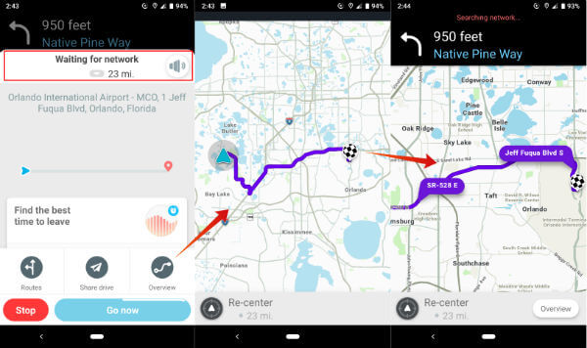iOS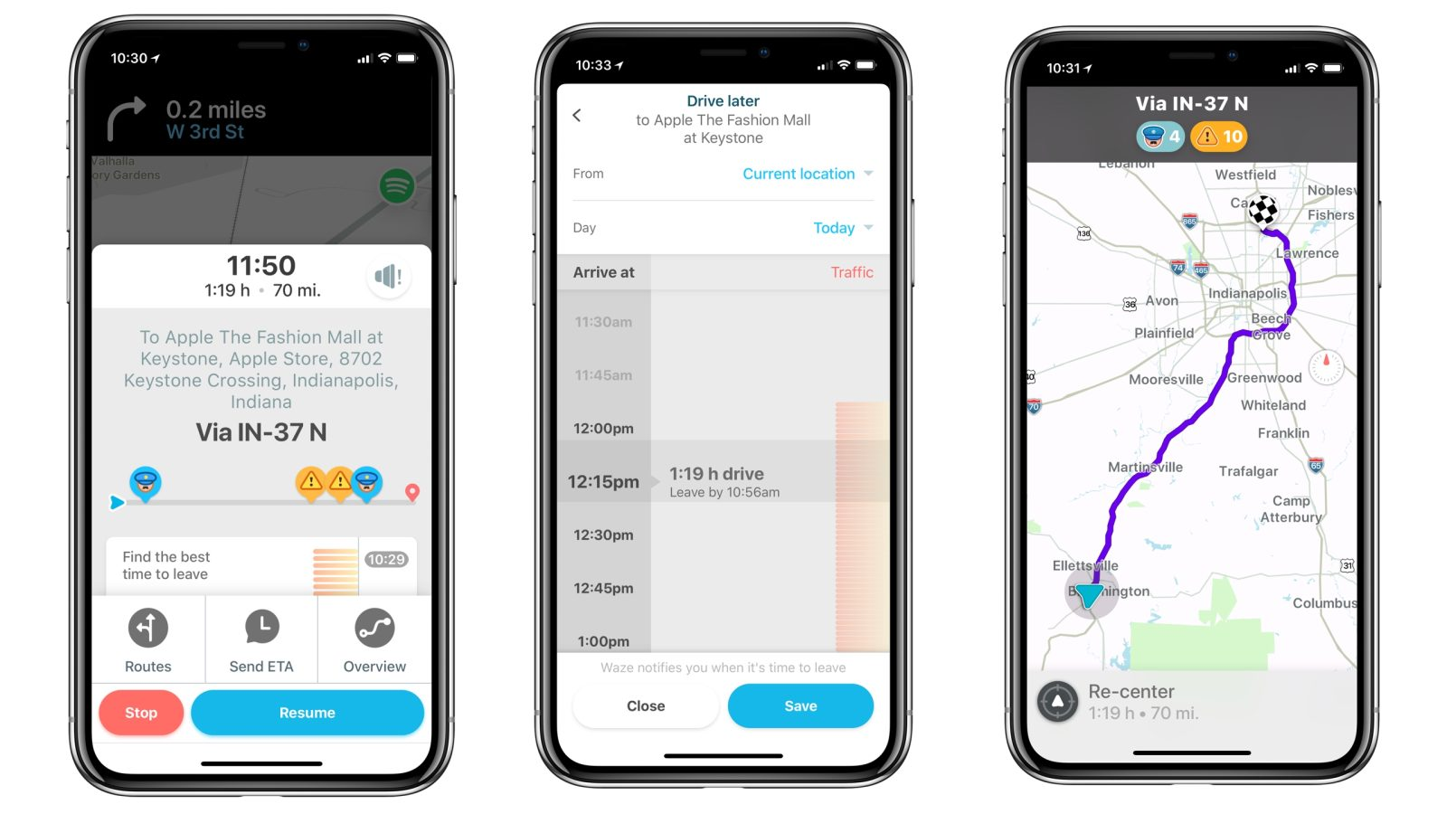

**Intended users**

Travellers

User needs, preferences and characteristics – how have they been met?

In order for someone to use the app, they will need to have access to Wi-Fi or Mobile Data.

The app also can be used via a Bluetooth. It has a special feature that allows the drivers car to be tracked, once the car is off and the connection is executed, it will then show that location the map wherever it was last connected.

**Purpose of app**

The purpose of the application is to be used as a satnav or a location finder. It is mostly used as a satnav. The app has many different features, for example, other users of Waze who allow to be seen can be seen on the map as a little character at their location while using, this only shows while within a vicinity.

**Current technologies**

What types of technology have been used in the development of the app?

* + Android, iOS.

Does the app make use of any particular technologies in its use?

* + The game uses GPS to recognise the location of the device and place it on a map that is real-time based.
  + The user interface is covered by the whole screen; it uses the touch screen in order for the user to interact.
  + The application requires Bluetooth for some of its use. It has a special feature that allows the drivers car to be tracked, once the car is off and the connection is executed, it will then show that location the map wherever it was last connected.

**Evaluate**

The application has many good features, for example, it has a special feature that allows the drivers car to be tracked, once the car is off and the connection is executed, it will then show that location the map wherever it was last connected. It also shows other users of Waze who allow to be seen can be seen on the map as a little character at their location while using, this only shows while within a vicinity.

However, the app uses lots of charge on the mobile device since it is required to be on and require to use data to check the data that other people have input about certain traffic speeds, speed cameras active or police spotting. The app asks for input for certain information while driving such as route changes which require diverting attention from driving which is a major distraction.

Final evaluation:

The Walking Dead: Our World - This game was developed by NextGames, based off of the TV show, the app follows the path of the legendary game Pokémon GO with its own version of getting people out and about on their phones. The game consists of many of the same ideas, it wants you to travel to locations to fight off numerous hordes of zombies and even place your base. Using this app while travelling mean you will be able to collect different items from the hordes as well as attack other bases. The app can be used with VR (similar to Pokémon Go), attacks can be done in VR so that your device uses your camera to show whatever is in front and the enemies on screen. The game has the ability to be used without the camera for AR, ability to use game features with accessibility functions, ability to play it on both Android and iOS and ability to play on tablet (Android and iPadOS). This is done by having a permission setting for the app meaning that it doesn’t have to use AR to be played. All apps on the App Store are compatible with accessibility function that are on iOS devices. The app is playable on both Android and iOS since it is on both the App Store and the Play Store. The app is available on the Play Store meaning it can be played on Android Tablets. The app is available on the App Store for iPads so it is available for iPadOS. The game uses GPS to recognise the location of the device and place it on a map that is real-time based. The application uses several device permissions, the application cannot be played without access to the internet since it feeds off of a server, it also needs the internet access for the map. It can use either Wi-Fi or mobile data to connect to their servers. The app needs permission for the camera in order to use Augmented reality however the game is still playable even without this function being allowed.

Netflix - Netflix is a completely different genre of application as opposed to TWD: Our World

Waze -